**EX NO 8**

**Aim**:

# To automate daily email reports using lambda function

1. Perform Email Verification for required Email Addresses using SES Verified Identities

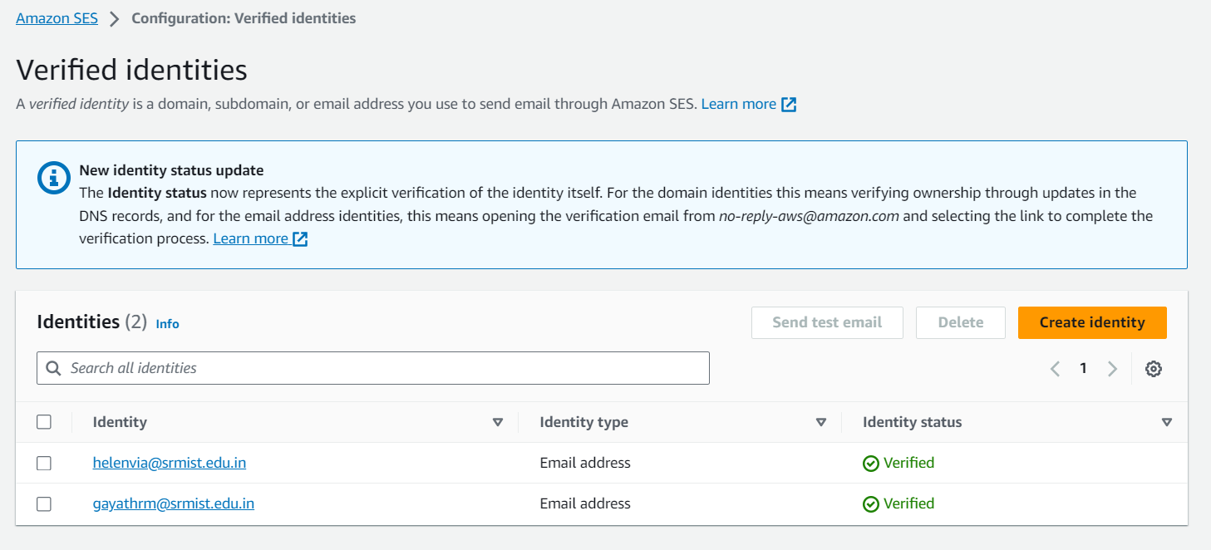

1. Create IAM Role and add AmazonSESFull Acess

3.Create Lambda function and add the above created role

**(Nodejs 16x)**

var aws = require("aws-sdk");

var ses = new aws.SES({ region: "us-east-1" });

exports.handler = async function (event) {

var params = {

Destination: {

ToAddresses: ["gayathrm@srmist.edu.in"],

},

Message: {

Body: {

Text: { Data: "Test" },

},

Subject: { Data: "Test Email" },

},

Source: "helenvia@srmist.edu.in",

};

return ses.sendEmail(params).promise()

};

4.Set the rules in Cloudwatch to automate the Email generation

To set cron

https://docs.oracle.com/cd/E12058_01/doc/doc.1014/e12030/cron_expressions.htm